## All India Coordinated Research Project on Agrometeorology

## CRIDA, Santoshnagar, Hyderabad – 500 059

Daily Crop Weather Information as on 05 July 2018

## Attention: Rajiv Maheshwari, OSD, ICAR

**Significant Weather Features (IMD)**

* The western part of the axis of monsoon trough at mean sea level now passes through Anupgarh, Narnaul, Aligarh, Hardoi, Behraich and the eastern part continues to lie close to the foothills of the Himalayas. Forecast meteorological conditions indicate that a cyclonic circulation is very likely to develop over northwest Bay of Bengal and adjoining west Bengal coast around 6th July. Along with this, the eastern part of the monsoon trough is very likely to shift southwards and occupy a near normal position from 7th July.
* Consequent changes in the monsoon flow pattern is very likely to cause an increase in rainfall over Karnataka, Maharashtra, Telangana and Andhra Pradesh from 6th July and over central India from 8th July.
* Sea conditions are very likely to remain very rough over eastcentral Arabian Sea and along and off Gujarat coast during next two days and over westcentral Arabian Sea during next 4 days. Fishermen are advised not to venture into these areas during the specified period.
* Yesterday, Extremely heavy rain occurred at isolated places over Meghalaya and Tripura and very heavy rain over Konkan and Gujarat Region.
* The images showing the latest satellite picture in figure. 1.

**Main Weather Observations (IMD)**

* Rainfall observed ( from 0830 hours IST of yesterday to 0830 hours IST of today): Rain/thundershowers observed at most places over Jammu & Kashmir, Himachal Pradesh, Uttarakhand, Punjab, Gujarat Region, East Madhya Pradesh, SubHimalayan West Bengal & Sikkim, Konkan & Goa, Coastal Karnataka and Andaman & Nicobar Islands; at many places over West Uttar Pradesh, Coastal Andhra Pradesh, Saurashtra & Kutch, Assam & Meghalaya, Nagaland, Manipur, Mizoram & Tripura,Gangetic West Bengal, Kerala and Madhya Maharashtra; at a few places over Haryana, Chandigarh & Delhi, East Uttar Pradesh, Jharkhand and West Madhya Pradesh and at isolated places over Bihar, Odisha, Vidarbha, Marathwada, Rajasthan, Interior Karnataka, Telangana, Rayalaseema and Tamilnadu & Puducherry. Amount of rainfall recorded at 0830 hours IST of today (5 cm or more) are: Sohra23, Bagdogra15, Mumbai (Santacruz)12, Matheran11, Jalpaiguri10, Surat9, Coochbehar and Bulsar8, Banda, Passighat, Diu, Dhanu, Mumbai (Colaba) and Alibag7 each, Dehradun, Pantnagar, Karnal. Krishnanagar and Majbat6 each and Ganganagar and Patiala5 each.
* Maximum temperature departures as on 03072018: Maximum temperatures were above normal (1.6°C to 3.0°C) at most places over Kerala and at isolated places over Saurashtra & Kutch, Madhya Maharashtra and East Uttar Pradesh. They were markedly below normal (5.1° C or less) at many places over Himachal Pradesh; at a few places over Jammu & Kashmir, Punjab; appreciably below normal (3.1° C to 5.0° C) at isolated places over Uttar Pradesh, SubHimalayan West Bengal & Sikkim and below normal (1.6° C to 3.0° C) at many places over Coastal Andhra Pradesh and Gujarat Region and at a few places over Konkan & Goa, Bihar, Assam & Meghalaya and Tamilnadu & Puducherry and near normal over rest of the country. The highest maximum temperature of 41.2°0C was recorded at Churu (West Rajasthan) over plains of the country.
* Minimum temperature departures as on 04072018: Minimum temperatures are above normal ( 1.6°C to 3.0°C) at a few places over SubHimalayan West Bengal & Sikkim, Odisha and at isolated places over Telangana,Rayalaseema,Tamilnadu & Puducherry and Saurashtra & Kutch. They are appreciably below normal (3.1° C to 5.0° C) at many places over Punjab and at isolated places over Himachal Pradesh and East Uttar Pradesh and below normal (1.6° C to 3.0° C) at a few places over Andaman & Nicobar Islands,West Uttar Pradesh, Haryana, Chandigarh & Delhi, Madhya Pradesh and Chhattisgarh and at isolated places over Konkan & Goa,Coastal Andhra Pradesh and Jammu & Kashmir and near normal over rest of the country.

**Weather Warning during next 5 days (IMD)**

* 04 July (Day 1): Heavy to very heavy rain with extremely heavy rain at isolated places very likely over Assam & Meghalaya; Heavy rain at a few places with very heavy rain at isolated places over Konkan & Goa; Heavy to very heavy rain at isolated places over Nagaland, Manipur, Mizoram & Tripura, SubHimalaya West Bengal & Sikkim and Gujarat Region and Heavy rain at isolated places over Arunachal Pradesh, Bihar, East Uttar Pradesh, Saurashtra , Chhattisgarh and Coastal Karnataka.
* 05 July (Day 2): Heavy rain at a few places with very heavy rain at isolated places very likely over Konkan & Goa; Heavy to very heavy rain at isolated places over Assam & Meghalaya, Gujarat Region and Coastal Karnataka and Heavy rain at isolated places over Arunachal Pradesh, SubHimalayan West Bengal & Sikkim, Saurashtra , Madhya Maharashtra, Vidarbha, Chhattisgarh and Telangana.
* 06 July (Day 3): Heavy to very heavy rain at a few places with extremely heavy rain at isolated places very likely over Konkan & Goa; Heavy rain at a few places with very heavy rain at isolated places very likely over Coastal Karnataka and Vidarbha; Heavy to very heavy rain at isolated places over Interior Karnataka and Heavy rain at isolated places over Assam & Meghalaya, Nagaland, Manipur, Mizoram & Tripura, Gangetic West Bengal, Odisha, Gujarat Region, Madhya Maharashtra, Marathawada, Chhattisgarh, Coastal Andhra Pradesh, Telangana and Kerala.
* 07 July (Day 4): Heavy to very heavy rain at a few places with extremely heavy rain at isolated places likely over Konkan & Goa; Heavy rain at a few places with very heavy rain at isolated places over Coastal Karnataka and Vidarbha; Heavy to very heavy rain at isolated places over Interior Karnataka and Kerala and Heavy rain at isolated places over Assam & Meghalaya, Nagaland, Manipur, Mizoram & Tripura, Odisha, Madhya Maharashtra, Marathawada and Chhattisgarh.
* 08 July (Day 5): Heavy to very heavy rain at a few places with extremely heavy rain at isolated places likely over Konkan & Goa; Heavy to very heavy rain at isolated places over Kerala and Heavy rain at isolated places over Arunachal Pradesh, Assam & Meghalaya, Nagaland, Manipur, Mizoram & Tripura, SubHimalayan West Bengal & Sikkim, Odisha, East Madhya Pradesh, Vidarbha, Chhattisgarh and Coastal & South Interior Karnataka.
* The weather outlook for the period of seven days i.e 01 to 09 July 2018 forecasted (Provided by Real-Time Weather Forecasts from NOAA/NCEP collected from http://monsoondata.org/wx2/) rain/thundershower may occur over Uttar Pradesh, Bihar, Chhattisgarh, Odisha, Eastern Madhya Pradesh, North eastern States, western coastal regions and light to moderate rainfall in some parts of Western and Peninsular India. (Fig. 2).

**Agricultural activities (AICRPAM-CRIDA)**

**Bijar**

**Weather condition**

Medium rainfall received in Bihar state for the past few days in the state. The maximum temperature ranges from 34 to 38°C and minimum temperature ranges from 23 to 27 °C.

**Contingency measure:**

* Advisory (Based on weather forecast) Kharif paddy Nursery Sowing/ Transplanting Complete the nursery sowing of medium duration rice crop. Sita, Santosh, Saroj, Rajshri, Prabhat, Rajendra suvasni, Rajendra kasturi and Rajendra bhagwati varieties of medium duration rice are recommended for North Bihar. Before sowing, seeds should be treated with Carbendazim@1.5 gram/kg of seed. Weeding is advised in 10-12 days old paddy nursery. Where seedlings are ready and irrigation facilities are available, farmers can start rice transplanting particularly in the medium and low land areas.
* Vegetables Sowing Weather is congenial for sowing of kharif vegetables. Farmers are advised to apply fertilizers based on soil test. If such test has not been done in their field, they are suggested to apply 20-25 tonnes of cow dung per hectare. Also apply 60 kg N, 50 Phosphorus and 40 kg potassium per hectare.
* Summer maize Harvesting In view of widespread rainfall activity in north Bihar districts during the forecast period, farmers are advised to take precaution in harvesting /threshing of summer maize.
* Sunflower Sowing Sowing of sunflower is advised in upland areas. Mordane, Surya, C O-1, Pairadevik and DRSF-108 for composite and BSH-1, KBSH-1, KBSH-44 and MSFH-1, MSHF-8 for hybrid varieties of sunflower are recommended for North Bihar. Application of 100 quintal FYM, 30 kg Nitrogen and 80 kg Phosphorus, 30-40 kg Potash per hectare is suggested during land preparation.Seed should be treated with thiram/captaaf @ 2 gram/ kg of seed.
* Sesamum (Til) Sowing Taking advantage of rainfall in the forecasted period, sowing of sesamum is advised in the upland areas. Krishna, Kaakee safed, Kalika, Pragati varieties are recommended for sowing in North Bihar. Application of 60 quintal compost, 20 kg Nitrogen, 20 kg Phosphorus and 20 kg Potash per hectare is advised during land preparation. Seed rate@ 4kg/ha is suggested. Before sowing, seed should be treated with Thiram@2gm/kg of seed.

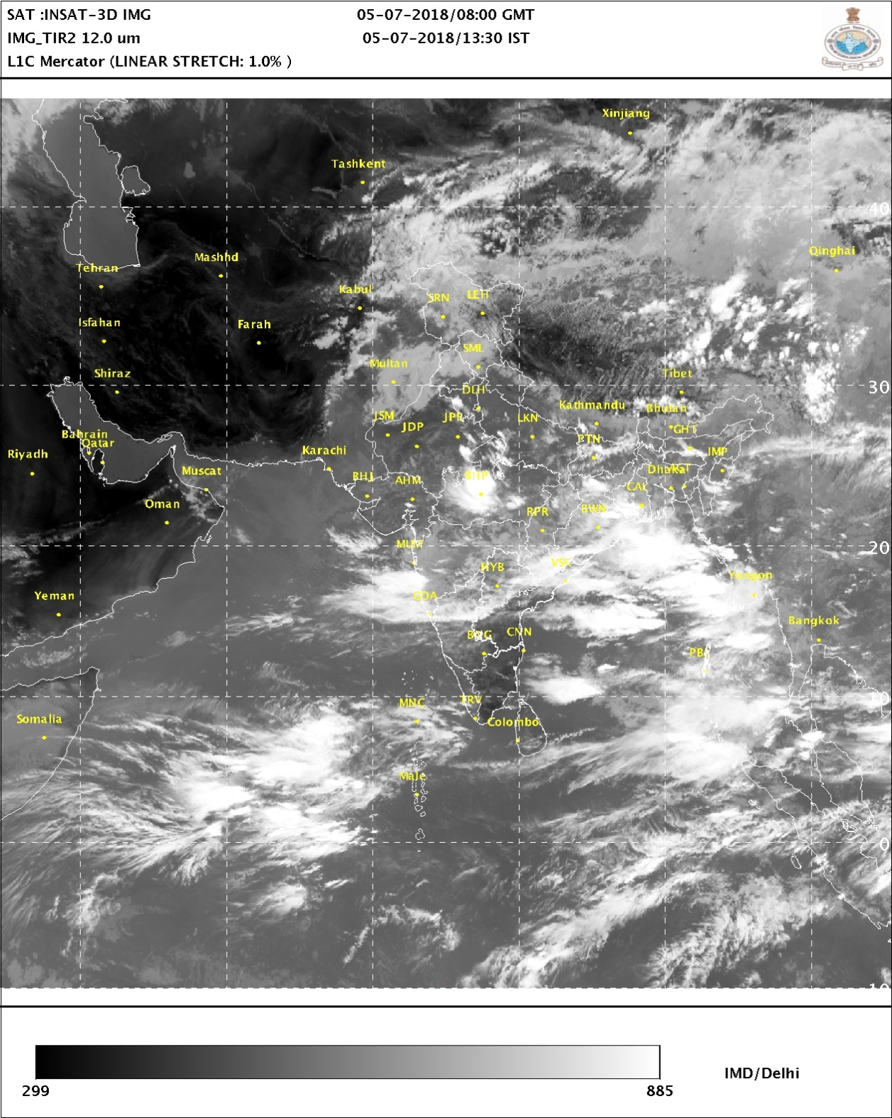

**Figure: 1. Latest available satellite picture as on 05 July 2018 at 15:30 Hrs (IST)**

**(Source: IMD).**

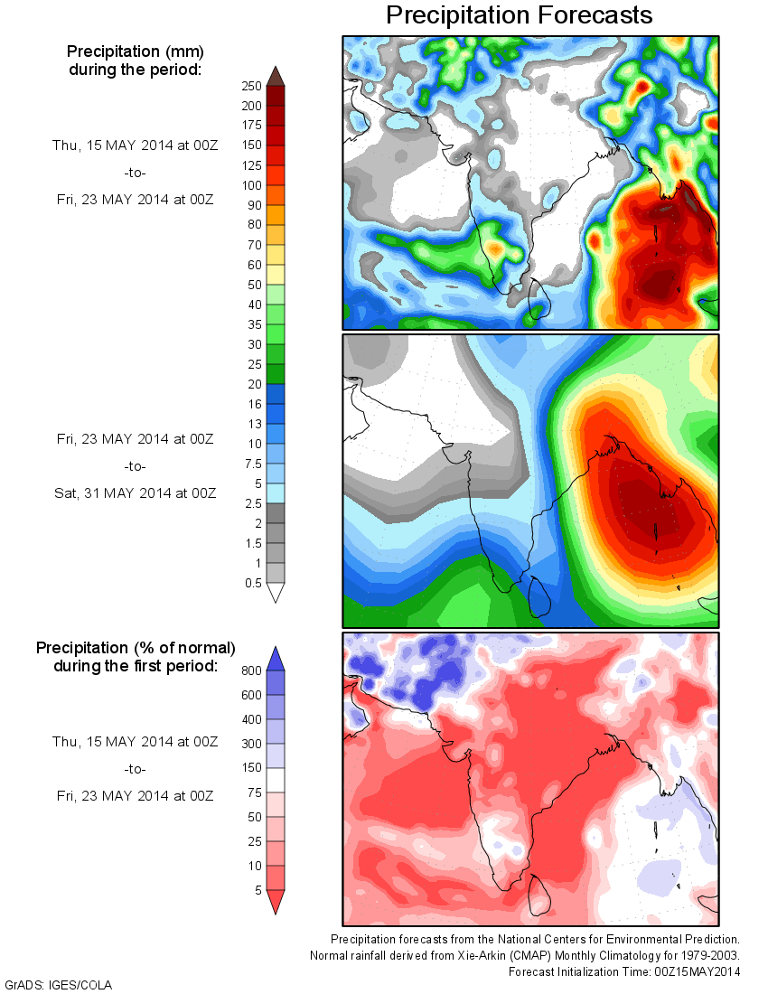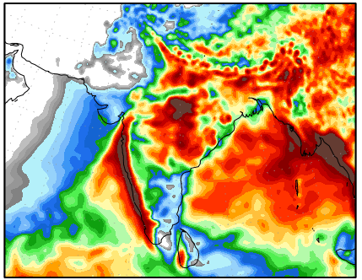

**Figure: 2. Precipitation forecast for 05 to 13 July 2018 (Source: NOAA NCEP).**